Ergebnisliste
Silhouette Scheiben Cup
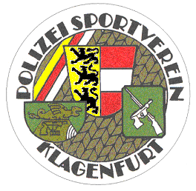

Air Pistol Production
7. Februar 2026
Einzelwertung
Rang | Name | Chicken | Pig | Turkey | Ram | Summe
1 | Heimo Machne | 5 | 10 | 7 | 10 | 32
2 | Fiedler Petra | 4 | 8 | 8 | 8 | 28
3 | Keuc Christoph | 7 | 6 | 5 | 9 | 27/8
4 | Themel Markus | 7 | 7 | 4 | 9 | 27/7
5 | Ortner Nikolaus | 7 | 8 | 5 | 3 | 23
6 | Sporis Friedrich | 3 | 7 | 5 | 7 | 22
7 | Rados Jakob | 4 | 3 | 5 | 7 | 19
7 | Driessler Michael | 2 | 8 | 5 | 4 | 19
9 | Bittner Karl | 4 | 6 | 3 | 4 | 17
10 | Hochmüller Elke | 2 | 4 | 3 | 6 | 15
11 | Trenner Georg | 2 | 5 | 3 | 3 | 13
11 | Bogner Dieter | 3 | 2 | 2 | 6 | 13
Mannschaft
Rang | Name | Chicken | Pig | Turkey | Ram | Summe
1 | SV zu Klagenfurt | 14 | 24 | 17 | 23 | 78
2 | SSV Sponheim | 15 | 20 | 16 | 21 | 72
3 | PSV Klagenfurt | 14 | 18 | 15 | 17 | 64
Klagenfurt, 7. 2. 2026

